**Name: Kanak Agrawal**

**Email:** [**kanakagrawal2001@gmail.com**](mailto:kanakagrawal2001@gmail.com)

**Date: 16-02-2024**

**Day-19 Assignment (Azure)**

**Here is the Hand Written Notes**

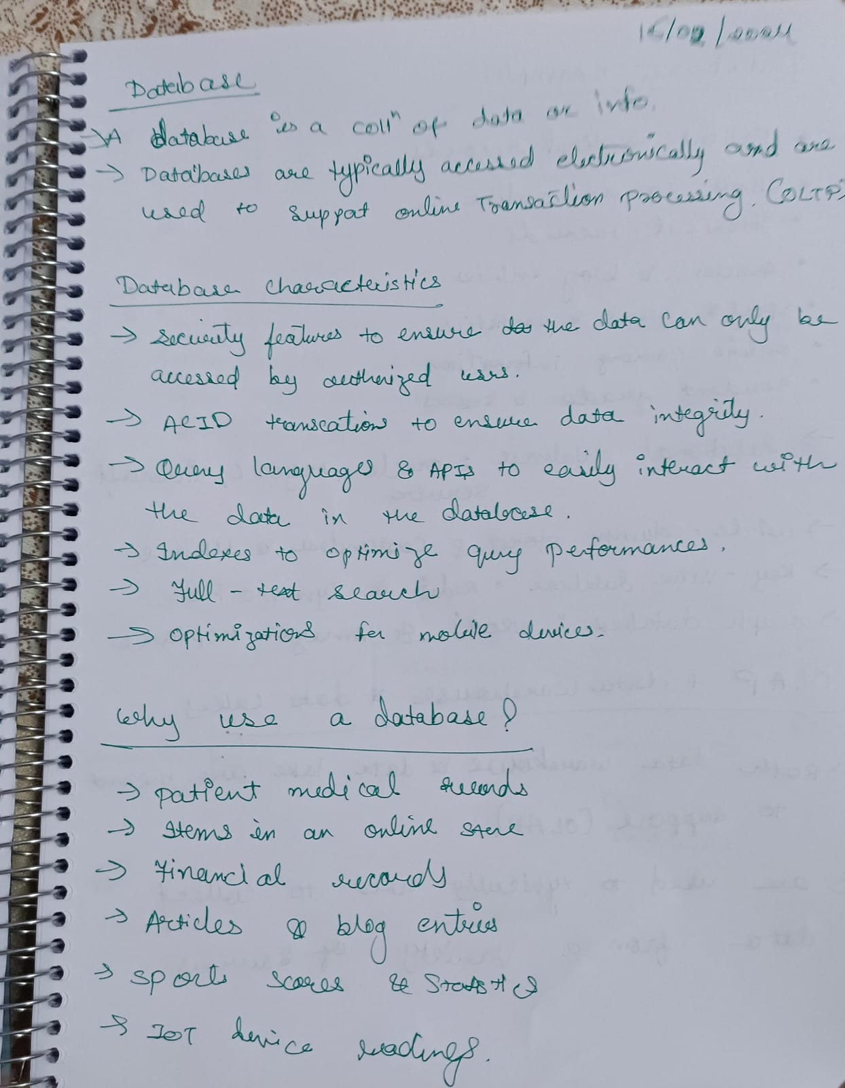

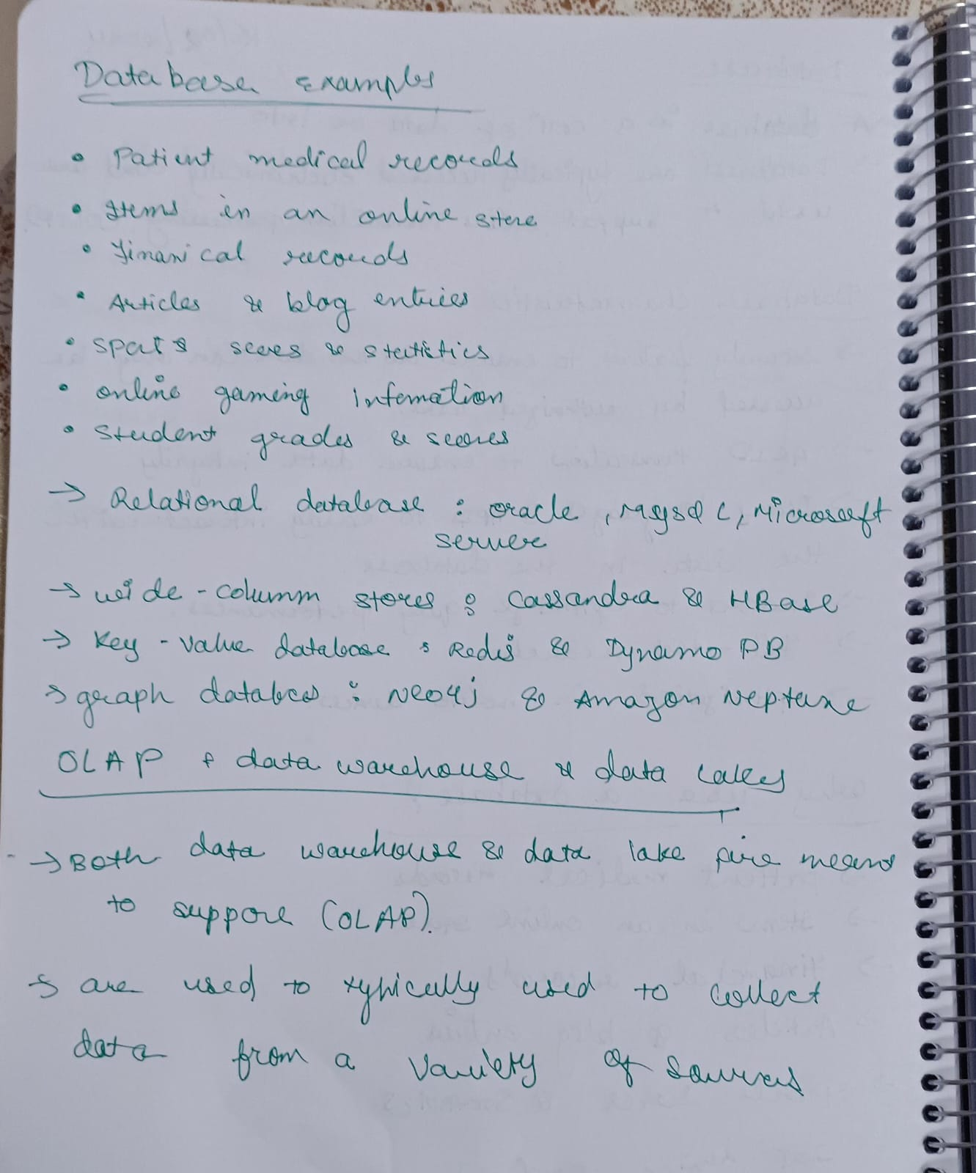

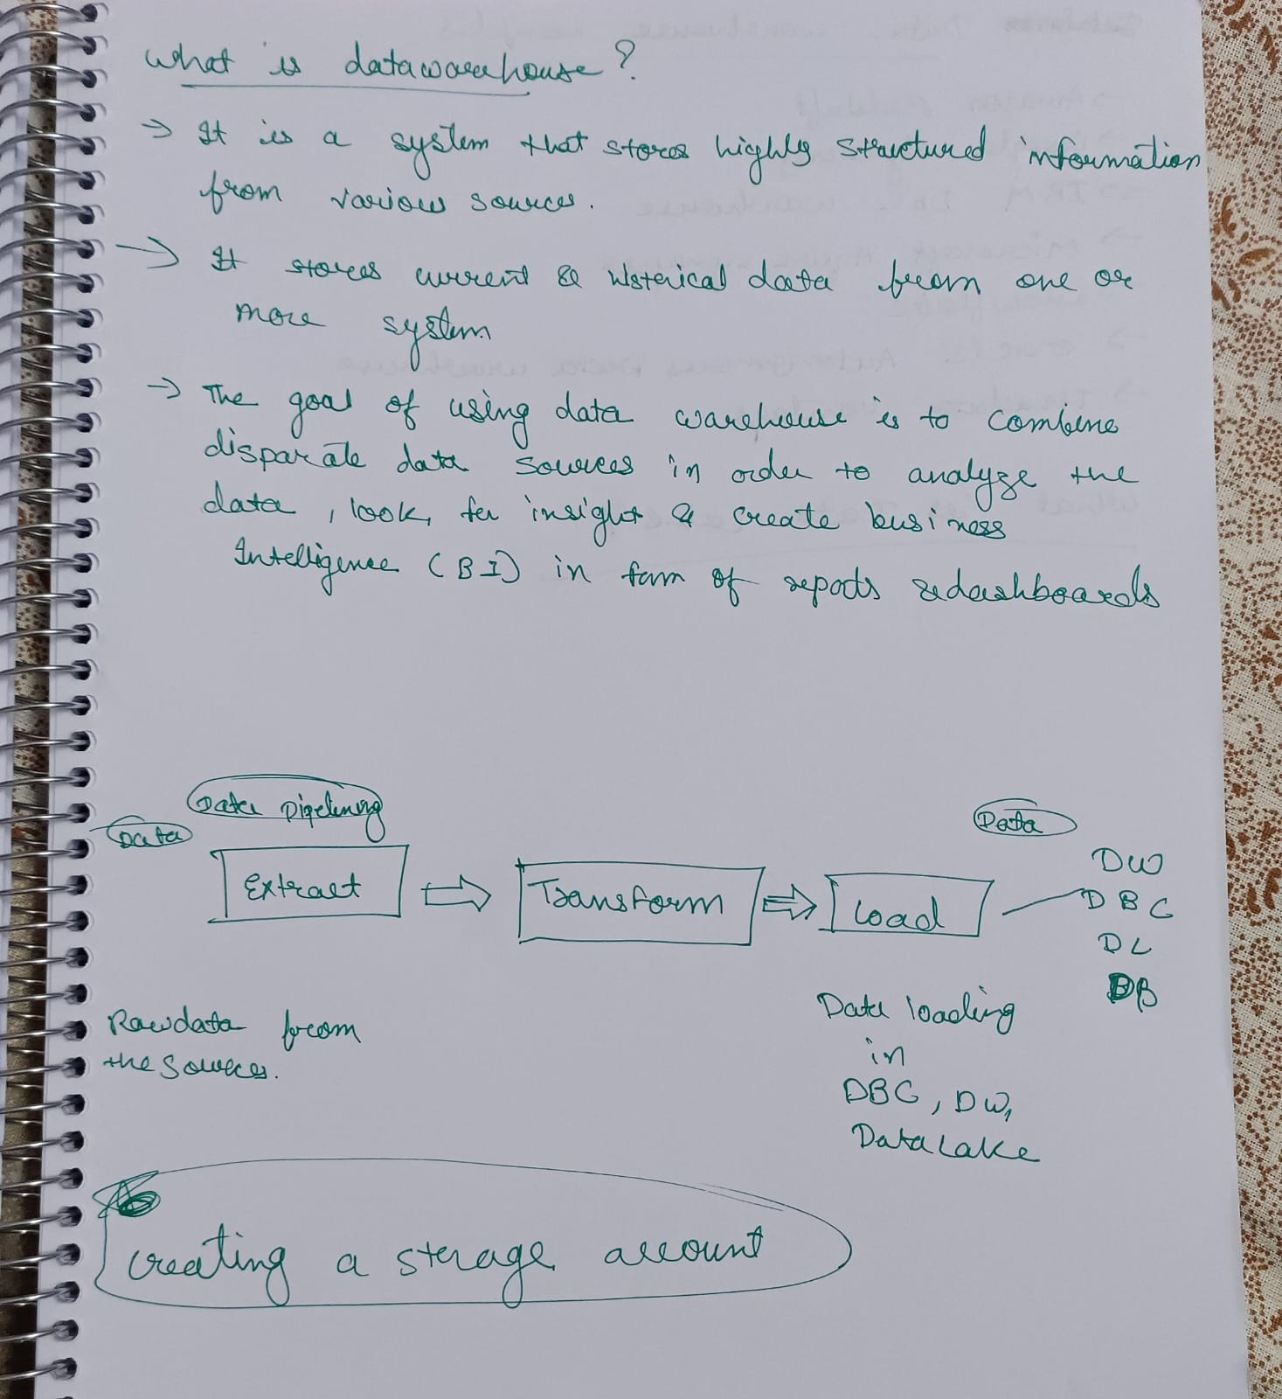

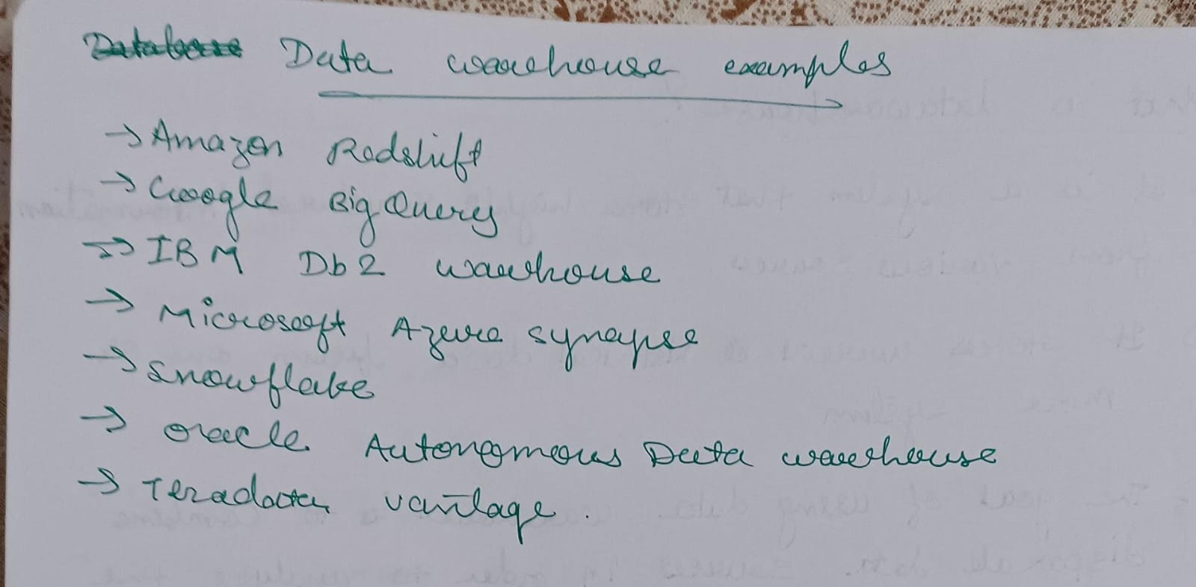

**Creating a storage table and here is the screenshot**

